# **NT4 Pauline 2: 1 & 2 Corinthians, Galatians, Ephesians, Philippians, Colossians**

Dr. Marvin J. Effa

**1 Corinthians**

**Author**: Paul, 1 Corinthians 1:1, writing from Ephesus, 1 Corinthians 16:8.

**Date of writing:** Dates range from 53-57 A.D.

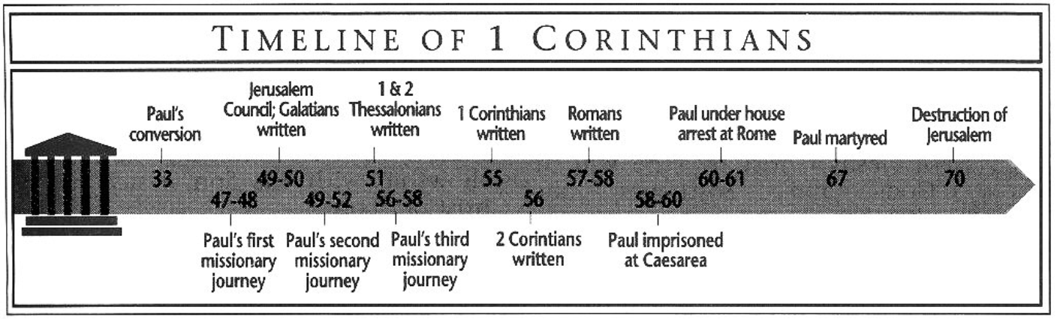 **Purpose**: to correct divisions, moral, and ethical problems in the church, and to answer questions previously provided to Paul.

**Idea**: Problems in people and the church can be corrected by apostolic revelation.

**Development:**

First Corinthians: Paul’s directions to a church full of divisions, immorality, carnality, and doctrinal error.

1. Carnal divisions are the work of the carnal believer and not the Spirit, 1-4.
2. Open immorality must be dealt with, 5.
3. Lawsuits and immorality do not glorify God, 6.
4. Paul answers questions about: marriage (7), pagan temples (8-10), masculinity/femininity (11), Communion (11), spiritual gifts in the worship service (12-14), 7-14.
5. Not every believer will die, but all will be resurrected similar to Christ’s resurrection, 15.
6. The church should send money to Jerusalem, 16.

**Key Passage Exegesis**

* The church must deal with serious, public sins when repentance is absent, 1 Corinthians 5.
* Paul addresses marriage and celibacy, 1 Corinthians 7.
* There are limits on a believer’s liberty, 1 Corinthians 8-10.
* A central passage on the resurrection, 1 Corinthians 15.

**2 Corinthians**

**Author**: Paul, 2 Corinthians 1:1.

**Date of writing:** Dates vary, but written shortly after 1 Corinthians.

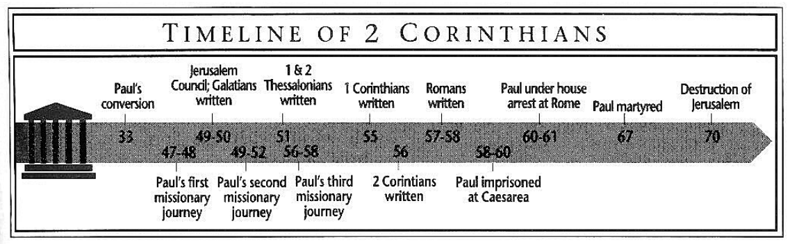

**Purpose**:

1. To cause the Corinthians to abandon the false apostles and follow Paul’s theology and commitment to both the Lord and the ministry.
2. To address certain administrative matters:
   1. Justify the change in his travel plans, 1:12-2:4.
   2. Restoration of a repentant brother, 2:6-11.
   3. Restart the Jerusalem Collection, 8:1-9:15.
3. To teach certain central doctrines:
   1. The superiority of the Spirit over the Law, 3:1-4:7.
   2. The temporary body for believers prior to the resurrection, 4:16-5:9.
   3. The judgment seat of Christ, 5:10-21.

**Idea**: Listening to false apostles will ruin your life.

**Development:**

1. Paul had planned to return shortly after the sorrowful letter, but didn't in order to spare them; plus, he hadn’t heard back from Titus. Now that Titus has reported to him, Paul instructs them to restore a repentant brother. 1:1-2:13.
2. The false apostles are merchandising both them and the Scriptures; they do not understand the decreasing of the person in surrender to the Spirit through the person and work of Christ. 2:14-5:21.
3. Paul and his group suffer greatly for the Corinthians’ stability; they should not have aligned themselves with the ungodly false apostles. 6:1-7:16.
4. Extra resources should be used to assist churches, not enrich false apostles. 8:1-9:15.
5. Paul is true apostle, with all of the marks of authenticity. 10:1-12:21.
6. The Corinthians have some serious choices to make as a church. 13:1-14.

**Key Passage Exegesis**

* God has given each believer a ministry of reconciliation, 2 Corinthians 3.
* When believers die, they are not disembodied spirits, 2 Corinthians 5.
* The central passage on New Testament giving, 2 Corinthians 8-9.

**Galatians**

**Author**: Paul, Galatians 1:1

**Date of writing:** The date is uncertain, but most conservative scholars take an early date.

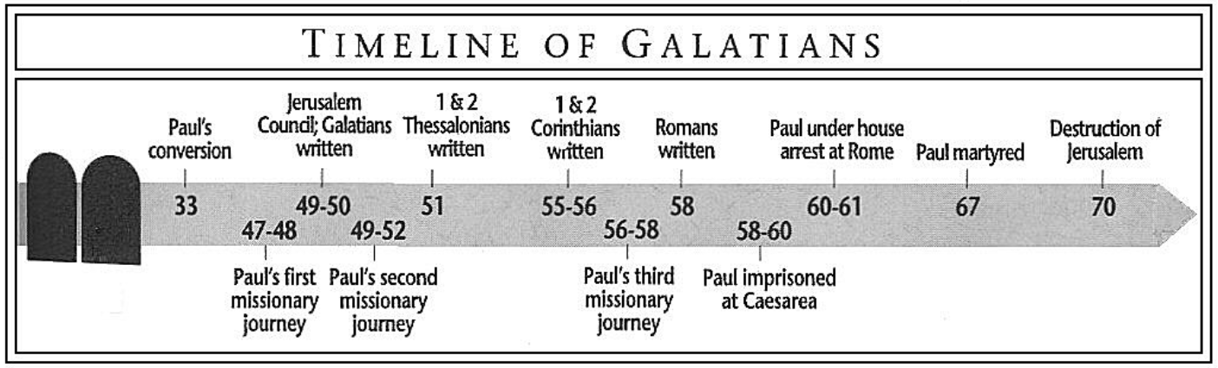

**Purpose**: The recipients had moved from the Gospel to a works-based system whereby faith was regarded as inadequate for one’s state and standing before God.

**Idea:** Accept the suffering that goes with a grace-based system.

**Development:** The book is a logical development and defense of the Gospel against the Mosaic Law vs. grace and works vs. faith. Each section follows logically upon the preceding.

Introduction (Gal. 1:1-5)

1. The Apostle Paul’s gospel will deliver us, 1:1-5.

**Never, Never add any works to the Gospel (Gal. 1:6-4:31)**

1. If we leave the gospel, we turn away from God, 1:6-9
2. Pleasing God (who gave him the Gospel) is Paul’s only concern, 1:10-2:14.
   1. One cannot please God and men, 1:10.
   2. While in Arabia, Jesus revealed the gospel to Paul, 1:11-17.
   3. The key apostles and leaders agreed with Paul’s gospel, 1:18-2:10.
   4. Peter sinned by returning to the law, 2:11-14.
3. Christ instructed the Apostles to leave the law, 2:15-21.
   1. No one can be justified by works, only by faith, 2:15-16.
   2. A return to law is sin, 2:17-19.
   3. The Christian life is lived by faith not by works, 2:20-21.
4. Abraham was justified by faith not by works, 3:1-15.
   1. Our experience validates faith, not works, 3:1-5.
   2. Abraham was justified by faith, 3:6-9.
   3. Christ redeemed us from the curse of the law, 3:10-14
      1. Law brings curses, 3:10-12.
      2. Christ was cursed so we could be blessed, 3:13-14.
5. The law cannot annul the promise, 3:15-29.
   1. Our inheritance comes from promise, 3:15-18.
   2. The law was to bring us to Christ, 3:19-25.
   3. Faith identifies us with Christ and makes us heirs, 3:26-29.
6. Heirs should not be slaves to the law, 4:1-31.
   1. The Son redeemed us from the law so we would be sons, 4:1-7.
   2. It is wrong to return to the law, 4:8-11.
   3. Follow Paul, not the slave-making false teachers, 4:12-20.
   4. Even the law teaches us not to return to the law! 4:21-31.

**Only the Spirit of Grace can produce love (Gal. 5:1-6:10)**

1. Stand in the liberty of Grace, 5:1-12.
   1. Christ will not help you if you turn to law, 5:1-3
   2. Only faith, not law, produces love, 5:4-6.
   3. The works-based teachers are NOT from God, 5:7-12.
2. Allow liberty to produce love, 5:13-6:10.
   1. Stop fighting and love one another, 5:13-15.
   2. Walk by the Spirit, not the flesh, 5:16-26.
   3. Restore others in humility, 6:1-5.
   4. By the Spirit, share and do good to all, 6:6-10.

**Conclusion (Gal. 6:11-18)**

1. Accept the suffering that goes with a grace-based system! 6:11-18.

**Key Passage Exegesis**

* All the Apostles were agreed on the Gospel, Galatians 1:18-2:14.

**Ephesians**

**Author**: Paul, Ephesians 1:1

**Date of writing:** 61 A.D. Written from Rome during his imprisonment listed in Acts 28.

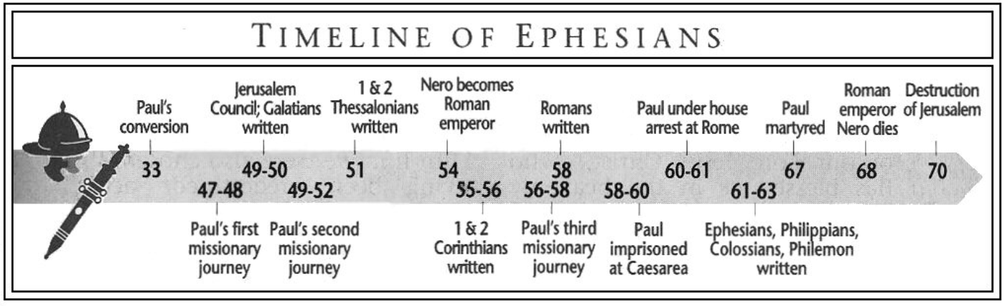

**Purpose**: to establish the equality of the Jew and Gentile in the body of Christ.

**Idea**: Since believing Gentiles are on equal footing with believing Jews they should walk worthily.

**Development:** Inheritance among the Saints

1. God’s amazing grace has brought Gentile believers into an eternal inheritance, Eph. 1:1-3:21.
   1. The Apostle Paul writes to saints and believers, 1:1-2.
   2. God wished, planned, and determined from the beginning that Gentiles should know His grace through Christ and receive an inheritance, 1:3-14.
   3. Paul prays that the Gentiles will understand the inheritance and the incredible power of the Messiah who is the head of the church, 1:15-23.
   4. Our serious sin was no match for God’s grace which will be demonstrated forever, 2:1-10.
   5. The war between Jew and Gentile is over; Gentiles are now fellow-citizens, 2:11-22.
   6. Paul, the Gentile’s apostle, declared the mystery of the fellow heirship, 3:1-13.
   7. Paul prays that we would comprehend God’s awesome grace, 3:14-21.
2. God’s grace transforms the person, the household, and the culture, Eph. 4:1-6:20.
   1. Our response to God’s grace should be the gracious exercise of our gifts, 4:1-16.
   2. Put off the Old Man; put on the New Man, 4:17-32.
   3. Inheritance in the kingdom requires living in the light and not the darkness, 5:1-21.
   4. Grace transforms the household, 5:22-6:9.
   5. Grace enables believers to stand against evil wherever we find it, 6:10-20.

**Key Passage Exegesis**

* The message of the church is new revelation, Ephesians 3.
* The longest household section Paul provided to the church, Ephesians 5-6.

**Philippians**

**Author**: Paul, Philippians 1:1.

**Date of writing:** 61 A.D. Written from Rome during his imprisonment listed in Acts 28.

**Purpose**: to thank the Philippian church for financial support and to address certain schisms.

**Idea**: The jailed apostle was deeply stirred by the church’s love—what a contrast to the Roman churches.

**Development:**

1. While longing for them, Paul has evangelized the jail; take courage from his suffering, 1.
2. We should follow Christ’s humility and allow the Gospel to transform us, 2.
3. Be on guard against legalists; walk by the Spirit with other believers, 3
4. Stop fighting, and strengthen the existing virtues, 4.

**Key Passage Exegesis**

* Christ’s humility serves as a model for believers, Philippians 2.

**Colossians**

**Author**: Paul, Colossians 1:1

**Date of writing:** 61 A.D. Written from Rome during his imprisonment listed in Acts 28.

**Purpose**: to warn the church about doctrinal error.

**Idea**: Godly living doesn’t come from philosophy or asceticism, but from the indwelling Christ.

**Development:**

1. God’s grace qualifies us for an inheritance in the coming Kingdom, Colossians 1:1-14.
2. Christ, who is over everything, reconciled us and gave Paul the revelation of the church, Colossians 1:15-29.
3. Do not allow philosophy or asceticism to cheat you, Colossians 2:1-23.
4. Put on the New Man and fulfill your household duties, 3:1-4:18.

**Key Passage Exegesis**

* + Christ is superior to all Jewish and secular philosophies, Colossians 1-2.